

Report 1

Members:

Justin Goulet, Chris Larsen, Mikal Callahan, Brock Corbett

Table of Contents

Executive Communication 5

Summary of Accomplishments: 5

Objectives of Next Phase: 5

Accrued Cost: 5

Estimated Cost: 5

Stakeholder Approval 5

Application Development 6

Statement of Business Context: 6

Statement of the Customer's Business Problem: 6

Statement of Project Proposal 6

Statement of Deliverables 6

What Medium Will the Product Be Delivered In 6

Outline of Project Measures of Success 6

Workflow Representation: 7

Requirements Matrix 8

Project Management 9

Section Objective 9

Introduction 9

Initial Project Cost Tracking Chart 9

Project Plan 10

Hold JAD 1 Meeting (2/8/17) 10

Hold JAD 2 Meeting (2/22/17) 10

Hold Prototype Meeting 1 (Deadline: 3/16/17) 10

Hold Prototype Meeting 2 (Deadline: 4/13/17) 10

Statement of the Deliverables 10

Estimated Costs - Phase 2 Due Date: 2/23/17 10

Resources Outline 11

What resources we will need from Northrop Grumman: 11

What resources we are supplying: 11

What resources we will need from the instructor: 11

Gantt Chart of Phases 11

Team Norms 12

Reliability 12

Commitment 12

Communication 12

Common Goal 12

Usrey, Thomas (Ty)

Northrop Grumman

16765 W. Bernardo Dr.

San Diego, CA 92127

Dear Mr. Usrey,

Hello, and welcome, to our Spring 2017 CSUSM Senior Project. We are looking forward to working together on this project and thank you for your support in allowing us to participate in your company task(s).

Before we dive into the project, I want to first introduce our team, Vortek Solutions. Many of us, myself included, worked together last semester on our own hosted website, BeerHopper.me. The creation of this website not only advanced our basic web skills, it advanced our relationships with one another to become a dedicated team.

While we all come from different backgrounds, we all have the same goal: to ensure you, our client, receives a project completed to the best of our ability that meets your pre-determined requirements.

Finally, while this is the majority of our team’s last semester before our Bachelors of Science degrees, we want to place our best feet forward and hope to work with you on your project as this is our best opportunity to present ourselves with real-world meetings, requirements and time management skills. We are an extremely dedicated team who wish to work with you on any alterations, deadline adjustments or functionality shifts that may arise - so long as it is in the defined Project Director’s scope.

If you have any questions or concerns in the duration of the project, please do not hesitate to message us in Slack® or email us with the address shown below. Thank you.

Justin Goulet

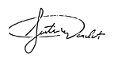

Project Manager / Lead

CIS 490 CSUSM

Project Management & Implementation

[VortekSolutions.CIS@gmail.com](mailto:VortekSolutions.CIS@gmail.com)

CC: Dr. Shaun-Inn Wu

# Executive Communication

## Summary of Accomplishments:

* Defined requirements:
  + What the widget is trying to accomplish (visualize workflow requirements)
  + Design requirements (e.g. colors, fonts, layout)
  + Performance requirements (e.g. error checking, data storage)
* Discussed communication methods
  + Ty now has access to specific slack channels
  + Ty has also been granted read access to our github channel
* Discussed how final product will be demoed
* Discussed project priorities (in order)
  + Workflow
  + Scheduling
  + Layout

## Objectives of Next Phase:

* Adjust requirements based on client feedback if necessary
* Finalize definition of workflow object
* Research and document possible technologies that could be used to solve the business problem
* Begin design of wireframes for widget

## Accrued Cost:

Consultation Fee ($35/hour):

1 hours * $35 = $35

Labor Fee ($25/hour):

10 hours * $25 = $250

$250/4 team members = $62.5 per team member

## Estimated Cost:

Labor Fee ($25/hour):

12 weeks * 10 hours per week * 4 employees = 480 hours

480 hours *$25 = $12000

# Stakeholder Approval

I                                                    (print), approve the current project and continuation under the predetermined terms by the Vortek Solutions team, will provide any non-confidential materials that contributes to the overall success of the project and will allow Vortek Solutions to manage all deliverables set by the project sponsor.

Client Signature: _____________________________ Date: ____ /____ /________

# Application Development

## Statement of Business Context:

Northrop Grumman has existing systems related to their manufacturing workflows. These systems run in a web browser showing statistics and information related to specific workflows. Created statistics are visualized in charts, or Visio style diagrams, which are not always easily read (especially on devices of various screen sizes such as the tablets used by upper management). The statistics and other pieces of information related to the workflows are then used in decision making at various levels throughout the organization.

## Statement of the Customer's Business Problem:

Northrop Grumman is in need of a versatile widget that would allow them to monitor their current workflow in an easy to process but highly descriptive manner. Currently the employees get this information printed out on a piece of a paper, but if we can provide a digital solution to this issue, this widget will help them identify areas in their workflow that are prone to delays or holdups, as well as areas that tend to be quicker than anticipated. This will help the company easily analyze its workflow processes.

## Statement of Project Proposal

We propose a widget that will be able to receive multiple workflow objects and render it in the multiple browsers that Northrop Grumman supports. The widget will also be able to be styled using CSS and have the ability to add, update and edit a workflow’s state.

## Statement of Deliverables

The deliverables will be:

* The final widget which will:
  + An executable, locally run widget, which interprets JSON data containing information of a specific workflow
  + Display workflows in a visual manner
  + Run on IE11+, Firefox 45+ and Edge.
* Documentation
* Source Code

## What Medium Will the Product Be Delivered In

Source code that our clients at Northrop Grumman will be able to compile and run on their local machines via web browser (IE11+, Edge, Firefox45+)

## Outline of Project Measures of Success

We will know that we have finished the widget when (after extensive testing) we are able to read in a JSON object full of workflow information and correctly display said workflow. The widget will also need to be dynamic in the sense that the user will have the ability to add, remove, or modify existing states from said workflow.

# Workflow Representation:

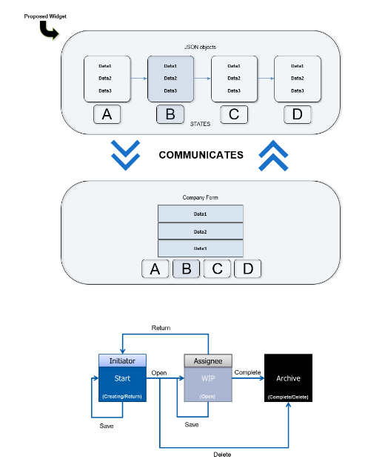

# Requirements Matrix

|  |  |  |  |  |
| --- | --- | --- | --- | --- |
| **Requirement #** | **Requirement** | **Diagram #** | **Module Name** | **Implemented**  **(Y/N)** |
| 1 | Receive JSON data from source |  |  |  |
| 2 | Widget must run on IE 11+ |  |  |  |
| 3 | Widget must run on Edge |  |  |  |
| 4 | Widget must run on Firefox 45+ |  |  |  |
| 5 | Render projected workflow steps |  |  |  |
| 6 | Render workflow info (project name, date started, etc) |  |  |  |
| 7 | Render workflow step linkages |  |  |  |
| 8 | Allow workflow’s current state to be changed to a different state |  |  |  |
| 9 | Allow additional state(s) to be added to the workflow |  |  |  |
| 10 | Allow states to be deleted |  |  |  |
| 11 | Allow widget to be themed with CSS |  |  |  |
| 12 | Widget must be able to handle JSON objects with incomplete data |  |  |  |

# Project Management

## Section Objective

To provide insight to the client as to how the project will be completed and to ensure consistency between client-team communications and management.

## Introduction

This project is to be conducted by the team Vortek Solutions from California State University, San Marcos in conjunction with Thomas (Ty) Usrey, representing Northrop Grumman.

The project requirements, outlined in this document, provide the functionality of the proposed system that the university must accomplish for successful submission. The project, as mentioned, is to either create or modify an existing system in order to match the outlined requirements. Starting with a widget for project workflow, this project will, if time permits, advance to additional resources such as a scheduler and layout (Visio-style) application.

## Initial Project Cost Tracking Chart

## Project Plan

### Hold JAD 1 Meeting (2/8/17)

#### On site

* Discuss communication methods
* Define customer requirements
* Interpret project priorities
* Discuss final product

### Hold JAD 2 Meeting (2/22/17)

#### On site

* Adjust requirements if needed
* Examine possible technologies to implement
* Finalize definition of workflow object

### Hold Prototype Meeting 1 (Deadline: 3/16/17)

#### On site

* Widget can accept JSON objects
* Widget display implemented
* Get feedback

### Hold Prototype Meeting 2 (Deadline: 4/13/17)

#### On site

* Widget given more functionality (modify/delete)
* CSS themed
* Error-handling
* Get more feedback for final product

## Statement of the Deliverables

**In the next phase,** our plan is to gather information on new technologies in order to find out what will suit our project the best. If we are able to finalize a technology to implement, our next task is to start working on the mockup for the widget. This includes design and documentation, which will eventually lead to implementation in the following phase.

### Estimated Costs - Phase 2 Due Date: 2/23/17

|  |  |  |  |
| --- | --- | --- | --- |
| **Task** | **Hours** | **Bill Rate** | **Total Cost** |
| Explore new technologies for widget | 40 | $25.00 | $1,000.00 |
| Create mockup for widget | 40 | $25.00 | $1,000.00 |
| **Total Hours:** | 80 | $25.00 | $2,000.00 |

## Resources Outline

### What resources we will need from Northrop Grumman:

* Due to the nature of Northrop Grumman’s industry/clientele we understand that we will have no access to Northrop’s internal network and production data.
* Ty has provided us with:
  + Sample workflow object data
  + Application style guide
  + List of commercial libraries that Northrop Grumman has access to.

### What resources we are supplying:

* We will provide a test environment to mimic how the widget will be deployed in production.
* Any open source software that is needed for research/ development purposes.
* Slack channel
* GitHub repository

### What resources we will need from the instructor:

* At this time we do not require anything of the instructor.

## Gantt Chart of Phases

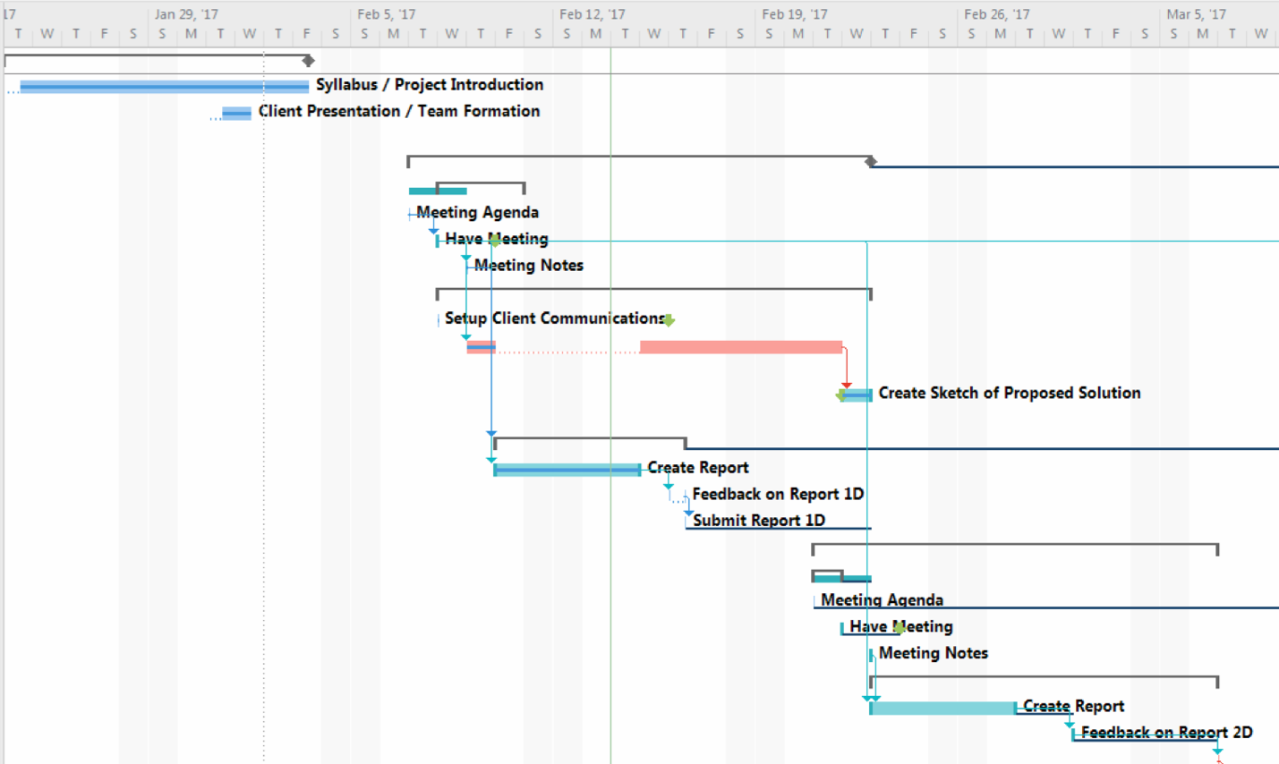

## Team Norms

### Reliability

Vortek Solutions strives to perform all of our tasks carefully and diligently, while still working in a swift manner, providing utmost reliability of our products. We take pride in our work, and reliability is of utmost importance.

### Commitment

Vortek Solutions is committed to our clients. We put in every effort to ensure all of our client’s needs are met, from the most prominent functional features to the smallest subtleties in design.

### Communication

At Vortek Solutions communication is key. We are in constant contact among each other and always ensure that the individual parts we are working on will amalgamate into one harmonious product. We also keep our clients up to date with our progress and send over updates as them come. We do not hesitate to ask any questions regarding our client’s needs and we are always open to questions and comments from our clients.

### Common Goal

Vortek Solutions strives to provide a product that is not just functional, but both beautifully built and intelligently designed. The ending result is a well built and carefully crafted product that is sure to leave our clients satisfied.

Client Signature:

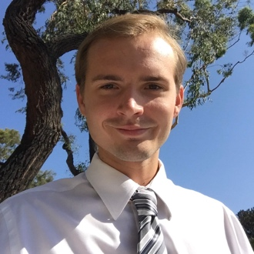

*Project Lead / Manager, UX*

I specialize in project management and modern design techniques.

In addition to design, I have experience developing for iOS (where I have several published applications), desktop (in Java, C++, C, C#), web (PHP, CSS, HTML, XML) and database.

I use excellent project management skills with proper communication, task management and documentation for all of my new projects with great interest in using third party integrations.



Justin Goulet

Chris Larsen

*Database and Sys Admin*

3 years of experience as Associate Systems Administrator for a local biotech with a focus on migration to cloud products.

I have experience working with C++, Java, HTML, CSS and PHP. I am a focused and goal oriented individual who will work hard to provide lean, innovative solutions.



*UI/UX Design & Development*

I specialize in UI/UX with a focus on modern yet intelligent design. I am experienced in HTML, CSS, JS/jQuery as well as various tools relating to web development, C++/Java, and database.

I am a problem solver who is good at improvisation when things do not go according to plan. Excellent time management and leadership skills. Diligent and detail oriented.

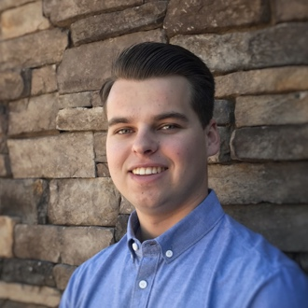

*Developer*

Proficient with C++, but also has experience with Ruby, HTML/CSS, JavaScript, and SQL.

Team player who has a strong attention to detail. Not afraid to learn new technologies and take on new tasks,

Brock Corbett

Mikal Callahan

|  |  |  |  |  |  |
| --- | --- | --- | --- | --- | --- |
|  | Monday | Tuesday | Wednesday | Thursday | Friday |
| 8 a.m. |  |  |  |  |  |
| 9 a.m. |  |  |  |  |  |
| 10 a.m. |  |  |  |  |  |
| 11 a.m. |  |  |  |  |  |
| 12 p.m. |  |  |  |  |  |
| 1 p.m. |  |  |  |  |  |
| 2 p.m. |  |  |  |  |  |
| 3 p.m. |  |  | **3 p.m.**  **-**  **4 p.m.** |  |  |
| 4 pm. |  |  |  |  |
| 5 p.m. |  |  |  |  |  |

*Optimal Availability\**

** Please contact for additional times and preferences.